**ASG 01**

**Name:** Yatharth Thakare

**Roll No:** 51

**PRN:** 12111403

**Subject:** SI

**Problem Statement :** Use real-world examples for regression analysis like predicting the price of a house given house features, or predicting the impact of SAT/GRE scores on college admissions, or predicting the sales based on input parameters, or prediction of whether.Use MSE to calculate the error and also provide the visualization of the output both for prediction and error.

**Linear Regression:** Linear regression is a statistical method used in machine learning and statistics to model the relationship between a dependent variable and one or more independent variables by fitting a linear equation to observed data.

**Goal:** To find the best-fitting line or plane that minimizes the distance between the observed data points and the predicted values generated by the linear model.

The linear equation takes the form :

Y=β0+β1X1+β2X2+...+βnXn+ϵ

**Univariate** **Linear Regression:** A type of linear regression with only one independent variable used to predict the value of a single dependent variable. The objective of univariate linear regression is to determine the best-fitting line that minimizes the sum of squared differences between the observed values and the values predicted by the linear model.

Y=β0+β1X+ϵ

**Multivariate Linear Regression:** Multivariate linear regression is a type of linear regression where there are multiple independent variables used to predict the value of a single dependent variable. The objective of multivariate linear regression is to determine the best-fitting plane (or hyperplane) that minimizes the sum of squared differences between the observed values and the values predicted by the linear model.

Y=β0+β1X1+β2X2+...+βnXn+ϵ

1. Loading Dataset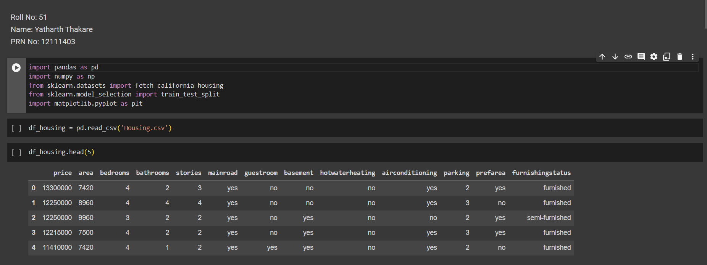
2. Data Preprocessing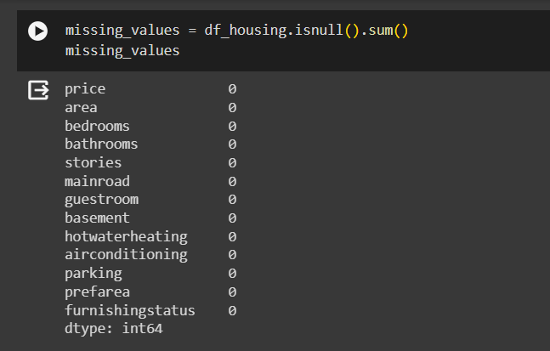

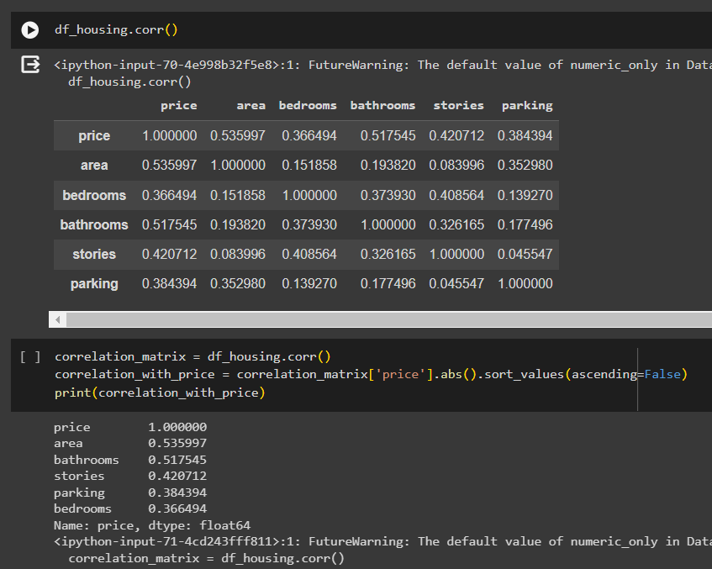

1. Train-Test Split

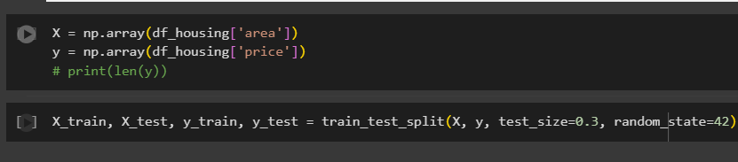

1. Implementing Linear Regression From Scratch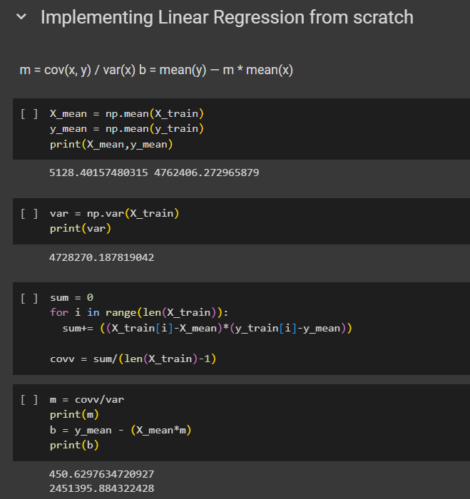

1. Predicting values for X test

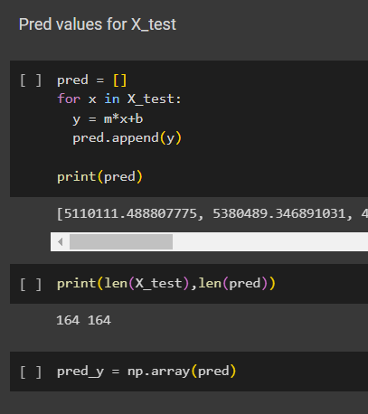

1. Output Plot and MSE

